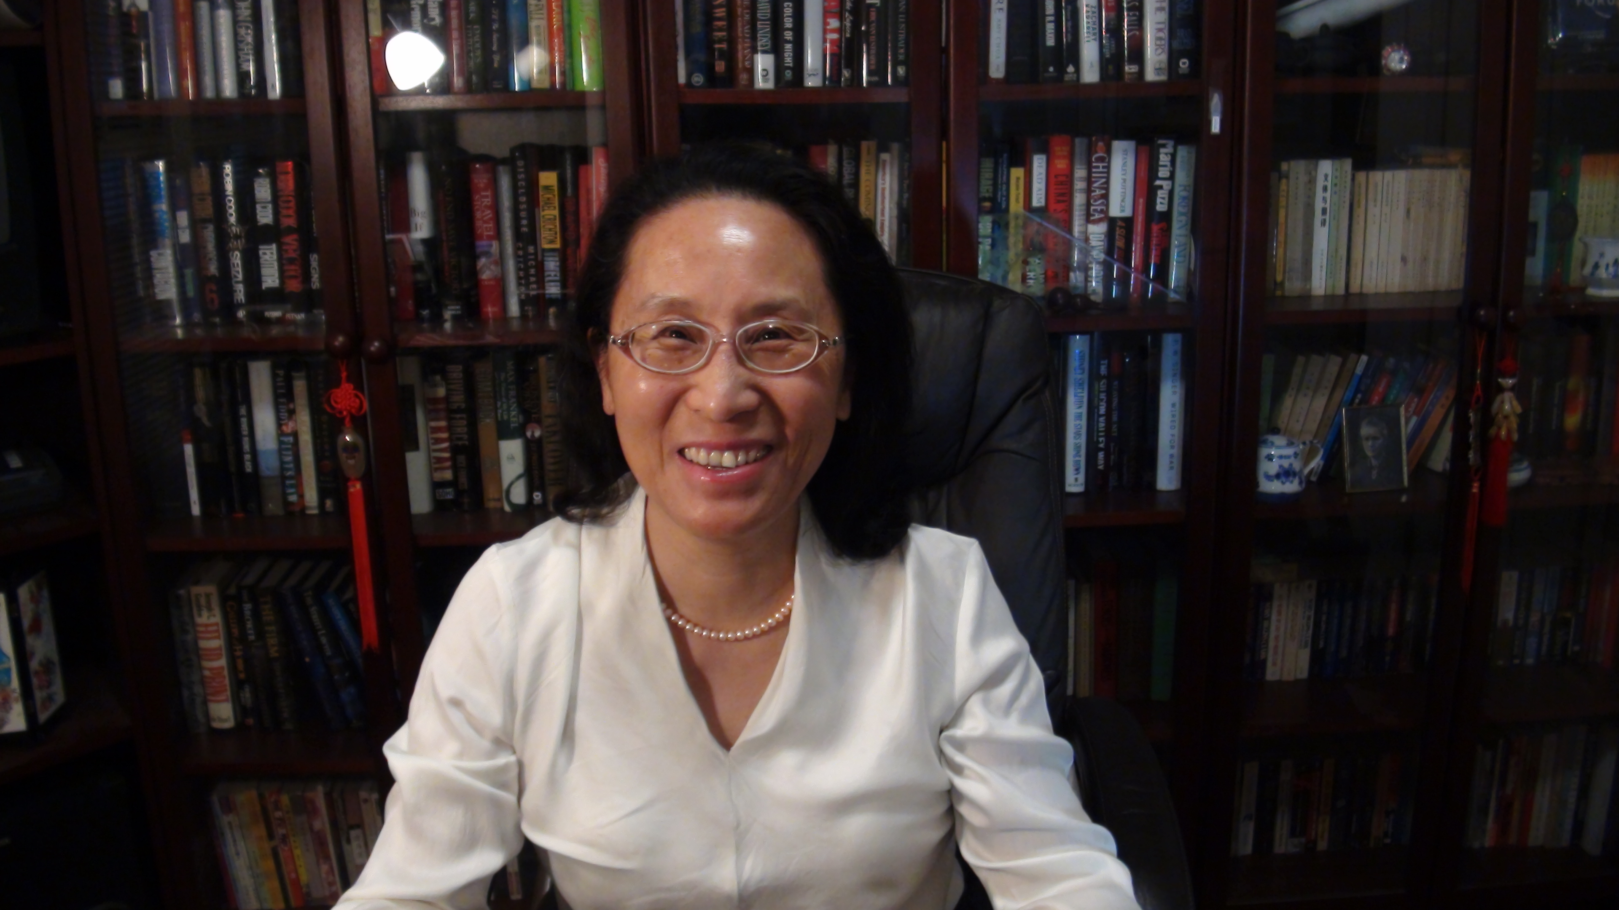
Sylvia Chen
Program Manager for East Asia and Pacific
Office of International Programs
U.S. Consumer Product Safety Commission

Sylvia Chen is Program Manager for East Asia and Pacific at the U.S. Consumer Product Safety Commission (CPSC). In that role, she is responsible for managing the Commission’s bilateral and multi-lateral programs related to consumer product safety in Australia, Japan, Korea, Taiwan and New Zealand. She also supports the CPSC’s work with China. Since she joined the CPSC in 2008, Sylvia has been working with product safety regulators, industry organizations, manufacturers, exporters, buyers and other sourcing professionals to provide them with guidance and technical support in understanding U.S. requirements, in particular the latest requirements for consumer products. To that end, she has organized or coordinated many of the agency’s international education and outreach activities.

A bilingual speaker in English and Mandarin Chinese, Sylvia played an instrumental role in launching CPSC’s Chinese language web resource center to disseminate information to Chinese regulators and stakeholders on U.S. requirements for manufacturing safer products. Sylvia also initiated CPSC’s China Product Hazard Monthly Summary Bulletin, a publication widely distributed among product safety regulators since May 2008 and read by stakeholders at major links in consumer product supply chains in China.

Prior to joining the CPSC, Sylvia was a print and radio journalist for 14 years, covering China and East Asian affairs. In 2002, she traveled with the White House Press Corps to cover President Bush’s visit to Japan, Korea, and China. She is a recipient of the 1997 New York Festivals International Radio Awards.

Sylvia has a Bachelor of Arts degree in English and American Literature from Peking University and a Master of Arts degree in Linguistics from Fudan University. In 1991, she graduated from The Ohio State University with a Master’s degree in East Asian Studies.

For a dozen years, Sylvia was an avid volunteer at Montgomery County Swim League and Montgomery Soccer Inc. In her spare time, she loves to read books and listen to classical music.

